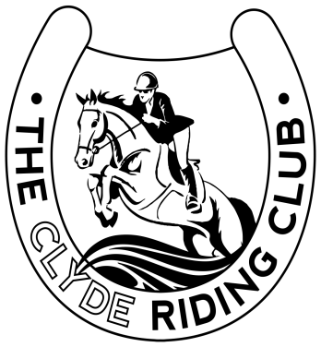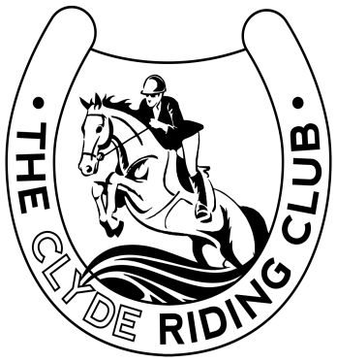
PRE-ENTRY ONLY
ARENA EVENT
ENTRY FORM
SUNDAY 10TH MARCH
Closing date for pre-entries is Sunday 3rd March. Late entries may be refused and will receive a £5 late entry fee.
Entry fees
Members: 2 rounds for £21 (incl. first aid)
Non-members: 2 rounds for £30 (incl. first aid and day membership fee)

Please wear appropriate clothing for cross country including a body protector and current standard hat.

Please complete and email this form to: theclyderidingclub@gmail.com with rider’s name as the subject of the email. We will post time slots on our Facebook page 48 hours before the event.
Name of Rider
Rider D.O.B
Age of Rider at 31/12/2018
Name of Mount
Height of Mount
Member (Y/N)
Phone number (in the event we need to contact you regarding your entry)
Arena Event Class(es) entered
Games (Y/N)
NOTE: A separate entry form must be used for each rider/horse combination, however only one day membership and first aid fee is applied per rider. Please state on your entry form that you are competing a second mount.
Please give any entry requirements/requests below: (for example, if you are riding another horse and want a gap between your rounds. We will do our best to meet any requests, but in the event that this is not possible, we will give you as much notice as possible)

Tick here if you would like to be informed of our future events via email □
Please see overleaf for payment details and also complete mandatory emergency contact details.

Emergency Contact Details | Below fields are mandatory
Full Name
Address
Contact Number
Email
Relation to Competitor

Payment details:
Entry fees to be paid by BACS transfer or PayPal with rider’s name as the reference to:
PayPal: accounts@theclyderidingclub.info (Helen Wilson)
or
BACS: The Clyde Riding Club
Sort code: 83-27-34
Account Number: 00632689
*please note if paying by BACS, we recommend that you save a screenshot/picture of your payment confirmation page for your records.*

The organisers of this event, or anyone acting on their behalf, do not accept any liability for any loss, damage, accident or injury to horses, riders, spectators or any other property whatsoever.
Please note we will need all competitors and (if under 18) their guardians to complete our liability disclaimer.
Please also familiarise yourself with our house rules.

Body protectors must be worn - Must be wearing a hat to BRC 2018 standards - No stallions - Horses must be 4 yrs. old or over - no dogs allowed

The Clyde Riding Club Liability Disclaimer
I __________________________ _____________________________
understand that all activities I participate in at any of The Clyde Riding Club’s events are taken at my own risk. I hereby sign this liability disclaimer and will accept all responsibility.

I agree not to bring ant claim against the organisers of this event(s). I have read and accept the terms of this liability disclaimer agreement.

Participant name: ________________________________________

Participant signature: _____________________________________

Date: __________________________________________________

For those under the age of 18 –

Parent/Guardian Name: ___________________________________

Parent/Guardian signature: ________________________________

Date: __________________________________________________

HOUSE RULES
- Unattended horses/ponies must not be left tied up outside trailers or horse boxes.
- Horses/ponies may only be tied up to tack/untack.
- No hay or haylage nets may be attached to the outside of trailers or horse boxes at any time.
- All horse droppings must be lifted from the car park and approaches to the arenas (the committee will deal with any in either the main or practice arenas).
- All rubbish must be placed in black bin bags provided.
- Show attire to be worn when competing
- Riding hats must conform to current BRC standards and may be subject to random checks by committee members
- Overuse of the whip will result in a judges’ warning and in cases of severe or repeat offences may result in disqualification from competition.
- No horses with red ribbons or a history of kicking to be allowed in the undercover waiting area
- Only horse or pony with rider/groom to be allowed in the undercover area – no spectators allowed.
- If a competitor falls off during their round, they must not remount their horse/pony while in the competition ring.
- Once completing your round please walk straight out of the arena and into the practice arena. To minimise the risk of accidents do not longer outside the entrance/exit of the show ring.
- All competitors and their guests must abide by our rules and by laws at all times. The committee reserve the right to eject any individual who they deem to be behaving inappropriately in any way. See no.19 in our constitution and rules.

